Client Consultation Form
  - Make-up
2022 version 1.0

Student name | Click or tap here to enter text. | ID # | Enter text.

Client Information
Client name | Click or tap here to enter text. |  |  | Cell # | Enter text.
Client address | Click or tap here to enter text.
Profession | Click or tap here to enter text.
Treatment date | Enter date. | Home # | Enter text. | Work # | Enter text.

Personal details
Age group | Choose age group. |  | Lifestyle |  | Active | ☐ | Sedentary |  | ☐
Last GP visit | Click or tap to enter a date.
GP name | Click or tap here to enter text.
GP address | Click or tap here to enter text.
No of children | Choose an item. | If applicable |  | Last period | Enter text. |  |  | If applicable

Contraindications
Contraindications requiring medical permission – where medical permission cannot be obtained, clients must give their informed consent in prior to treatment. Select if / when appropriate:
Medical oedema | ☐ | Nervous / psychotic conditions | ☐ | Epilepsy | ☐
Recent facial operations affecting the area | ☐ | Diabetes | ☐ | Skin cancer | ☐
Slipped disc | ☐ | Undiagnosed pain | ☐ | When taking prescribed medication | ☐
Whiplash | ☐

Contraindications that restrict treatment –Select if / when appropriate:
Fever | ☐ | Contagious or infectious diseases | ☐ | Under the influence of recreational drugs or alcohol | ☐
Diarrhoea and vomiting | ☐ | Any known allergies | ☐ | Eczema | ☐
Undiagnosed lumps and bumps | ☐ | Localised swelling | ☐ | Inflammation | ☐
Cuts | ☐ | Bruises | ☐ | Abrasions | ☐
Scar tissue (2 years for major operation and 6 months for small scar) | ☐ | Sunburn | ☐ | Conjunctivitis | ☐
Hormonal implants | ☐ | Recent fractures (minimum 3 months) | ☐ | Sinusitis | ☐
Neuralgia | ☐ | Migraine / headache | ☐ | Hypersensitive skin | ☐
Botox / dermal fillers (1 week following treatment) | ☐ | Hyper-keratosis | ☐ | Skin allergies | ☐
Styes | ☐ | Watery eyes | ☐ | Trapped / pinched nerve affecting the treatment area | ☐
Inflamed nerve | ☐ | Eye infection | ☐

Skin Test
Skin test – Select if / when appropriate
Moisture content | Excellent | ☐ | Good | ☐ | Fair | ☐ | Poor | ☐
Muscle tone | Excellent | ☐ | Good | ☐ | Fair | ☐ | Poor | ☐
Elasticity | Excellent | ☐ | Good | ☐ | Fair | ☐ | Poor | ☐
Sensitivity | High | ☐ | Medium | ☐ | Low | ☐
Skin’s healing ability | Excellent | ☐ | Good | ☐ | Fair | ☐ | Poor | ☐
Skin tone | Fair | ☐ | Medium | ☐ | Dark | ☐ | Olive | ☐
Circulation | Good | ☐ | Normal | ☐ | Poor | ☐
Pores | Fine | ☐ | Dilated | ☐ | Comedones | ☐ | Milia | ☐
Overall skin type | Click or tap here to enter text.

Treatment Information
Treatment to include  Select where appropriate | Day make-up | ☐ | Evening make-up | ☐ | Special occasion make-up | ☐
 | Bridal make-up | ☐ | Other make-up (specify) |  | Enter text.
 | Face shape | Click or tap here to enter text.
 | 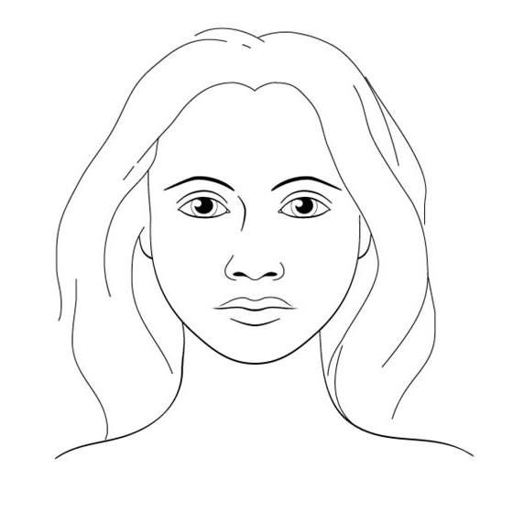
Draw corrective work
- Shader
- Highlighter
- Blusher

Treatment aim and details – To include products and colours used, make-up chart and before and after photographs
Click or tap here to enter text.

Make-up chart
Pre-base | Enter text. | Highlighter | Enter text.
Concealer | Enter text. | Eye shadow | Enter text.
Corrective cream | Enter text. | Eye liner | Enter text.
Foundation | Enter text. | Mascara | Enter text.
Powder | Enter text. | Lip liner | Enter text.
Blusher | Enter text. | Lipstick | Enter text.
Shader | Enter text. | Lip gloss | Enter text.

Client feedback
Click or tap here to enter text.

Aftercare / home care advice
Click or tap here to enter text.

Therapist’s signature

Client’s signature

BEFORE and AFTER PHOTOGRAPHS must be attached
Your signature indicates these photographs and case studies are your own work. Plagiarised, copied, or colluded work will be dealt with under our Academic Integrity policies.

