Client Consultation Form
  - Skin Care and Eye Treatments, and Facial Electrical Treatments
2022 version 1.0

Student name | Click or tap here to enter text. | ID # | Enter text.

Client Information
Client name | Click or tap here to enter text. |  |  | Cell # | Enter text.
Client address | Click or tap here to enter text.
Profession | Click or tap here to enter text.
Treatment date | Enter date. | Home # | Enter text. | Work # | Enter text.

Personal details
Age group | Choose age group. |  | Lifestyle |  | Active | ☐ | Sedentary |  | ☐
Last GP visit | Click or tap to enter a date.
GP name | Click or tap here to enter text.
GP address | Click or tap here to enter text.
No of children | Choose an item. | If applicable |  | Last period | Enter text. |  |  | If applicable

Contraindications: Skin Care and Eye Treatments Contraindications
Contraindications requiring medical permission – where medical permission cannot be obtained, clients must give their informed consent in prior to treatment. Select if / when appropriate:
Medical oedema | ☐ | Diabetes | ☐ | When taking prescribed medication | ☐
Nervous / psychotic conditions | ☐ | Skin cancer | ☐ | Whiplash | ☐
Epilepsy | ☐ | Slipped disc | ☐ | Undiagnosed pain | ☐
Recent facial operations affecting the area |  |  | ☐

Contraindications that restrict treatment –Select if / when appropriate:
Fever | ☐ | Bruises | ☐ | Sunburn | ☐
Contagious or infectious diseases | ☐ | Abrasions | ☐ | Migraine / headache | ☐
Under the influence of recreational drugs or alcohol | ☐ | Scar tissue (2 years for major operation and 6 months for small scar) | ☐ | Hypersensitive skin | ☐
Diarrhoea and vomiting | ☐ | Sunburn | ☐ | Botox / dermal fillers (1 week following treatment) | ☐
Any known allergies | ☐ | Conjunctivitis | ☐ | Hyper-keratosis | ☐
Eczema | ☐ | Hormonal implants | ☐ | Skin allergies | ☐
Undiagnosed lumps and bumps | ☐ | Recent fractures (minimum 3 months) | ☐ | Styes | ☐
Localised swelling | ☐ | Sinusitis | ☐ | Watery eyes | ☐
Inflammation | ☐ | Bruises | ☐ | Trapped / pinched nerve affecting the treatment area | ☐
Cuts | ☐ | Neuralgia | ☐ | Inflamed nerve | ☐
Eye infection | ☐

Contraindications: Facial Electrical Treatments Contraindications
Contraindications requiring medical permission – where medical permission cannot be obtained, clients must give their informed consent in prior to treatment. Select if / when appropriate:
Pregnancy | ☐ | Cardiovascular conditions | ☐ | Haemophilia | ☐
Any condition being treated by a GP or another practitioner | ☐ | Medical oedema | ☐ | Osteoporosis | ☐
Nervous / psychotic conditions | ☐ | Epilepsy | ☐ | Recent operations | ☐
Diabetes | ☐ | Asthma | ☐ | Any dysfunction of the nervous system | ☐
Bell’s palsy | ☐ | Trapped / pinched nerve | ☐ | Inflamed nerve | ☐
Spastic conditions | ☐ | Kidney infections | ☐ | Acute rheumatism | ☐
Undiagnosed facial pain | ☐ | When taking prescribed medication | ☐

Contraindications that restrict treatment –Select if / when appropriate:
Fever | ☐ | Contagious or infectious diseases | ☐ | Under the influence of recreational drugs or alcohol | ☐
Diarrhoea and vomiting | ☐ | Hypersensitive skin | ☐ | Skin diseases | ☐
Undiagnosed lumps and bumps | ☐ | Localised swelling | ☐ | Inflammation | ☐
Cuts | ☐ | Bruises | ☐ | Abrasions | ☐
Scar tissue (2 years for major operation and 6 months for small scar) | ☐ | Sunburn | ☐ | Hormonal implants | ☐
Haematoma | ☐ | Recent fractures (minimum 3 months) | ☐ | Cervical spondylitis | ☐
Any metal pins or plates | ☐ | Loss of skin sensation (test with tactile test) | ☐ | Sinusitis | ☐
Botox / dermal fillers (1 week following treatment) |  |  | ☐

Client’s Concerns and Current Skin Care Routine
Main concern | Click or tap here to enter text.
Current skin care routine | Click or tap here to enter text.

Treatment Information
Treatment to include  Select where appropriate | Superficial cleanse | ☐ | Skin analysis | ☐ | Eyebrow tweezing | ☐
 | Deep cleanse | ☐ | Lash tinting | ☐ | Massage | ☐
 | Pre-heat treatment | ☐ | Brow tinting | ☐ | Mask | ☐
 | Other treatments (specify) |  | Click or tap here to enter text.
 | Facial electricals (specify) |  | Click or tap here to enter text.

Skin Test
Skin test – Select if / when appropriate
Moisture content | Excellent | ☐ | Good | ☐ | Fair | ☐ | Poor | ☐
Lipid content | Excellent | ☐ | Good | ☐ | Fair | ☐ | Poor | ☐
Muscle tone | Excellent | ☐ | Good | ☐ | Fair | ☐ | Poor | ☐
Elasticity | Excellent | ☐ | Good | ☐ | Fair | ☐ | Poor | ☐
Sensitivity | High | ☐ | Medium | ☐ | Low | ☐
Skin’s healing ability | Excellent | ☐ | Good | ☐ | Fair | ☐ | Poor | ☐
Skin tone | Fair | ☐ | Medium | ☐ | Dark | ☐ | Olive | ☐
Circulation | Good | ☐ | Normal | ☐ | Poor | ☐
Pores | Fine | ☐ | Dilated | ☐ | Comedones | ☐ | Milia | ☐
Overall skin type | Click or tap here to enter text.
Key: | 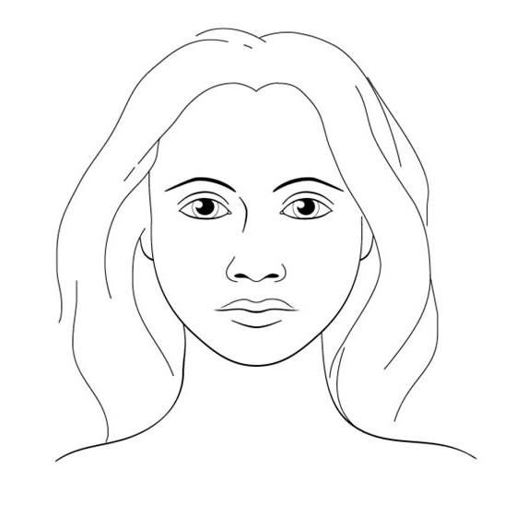

Treatment aim and details – To include products and equipment used
Click or tap here to enter text.

Client feedback
Click or tap here to enter text.

Aftercare / home care advice
Click or tap here to enter text.

Therapist’s signature

Client’s signature

Cardiovascular conditions can include: thrombosis, phlebitis, hypertension, hypotension, heart conditions
Examples of nervous system dysfunctions: multiple sclerosis, Parkinson’s disease, motor neurone disease

